第三章 遗传的染色体学说与连锁分析
答案
1．F 中的血型 A︰O＝75％︰25％＝3︰1，所以 F 的基因型为I^{A}i；而 F 中患病者与正常人的比例也是 3︰1，所以 F 的基因型为 Nn，N 为显性致病等位基因。F 中四种性状比值显著偏离9︰3︰3︰1，所以N 和IA 连锁。题目所给的条件可用遗传学的方法表示如下：
F₂ 中只有表型正常的O 型后代（比例占16％）具有确定的基因型（n i/n i）。设N 和I^{A}之间的重组率为 x，则 n i/n i 后代所占的比例 = (1/2) (1-x)·(1/2)(1-x) = 16%，即 x = 0.2。
也就是说，这两个基因之间的距离为 20 m.u.。
2．（1）a－b：100% (91＋9) /1001=10 cM，
b－c：100% (171＋9) /1001=18 cM。
（2）并发系数为 0.5。
3．v－b：18.0 cM；b－y：28.0 cM；并发系数为 0.79。
v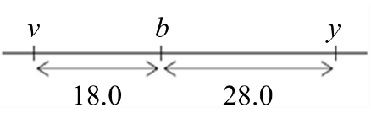
4．（1）3 个性状都像火星人：34%；
（2）3 个性状都像地球人：34%；
（3）火星人的耳朵和心脏，但是地球人的肾上腺：1.5%；
（4）火星人的耳朵，但是地球人的心脏和肾上腺：6%。
5．设血友病致病等位基因为 X^{h}，对应的野生型等位基因为 X^{H}；致色盲的等位基因为 X^{c}，对应的野生型等位基因为 X^{C}。则 II 的基因型是 X^{Hc}/Y；II 的父亲正常，所以 II 的基因型为 X^{HC}/X^{hc}。
据此，III₄ 的基因型 90％的可能性为 X^{HC}/X^{Hc}（此时后代不会得血友病），10%的可能性为 X^{hC}/X^{Hc}（交换的结果，男性后代有 1/2 的可能性得血友病）；因此，其儿子患血友病的概率为 1/2×1/10＝5%；
III₅ 的基因型 90％的可能性为 X^{hc}/X^{Hc}（男性后代有 1/2 的可能性得血友病），10％的可能性为 X^{Hc}/X^{Hc}（交换的结果，此时后代不会得血友病）。因此，她的儿子得血友病的概率为 1/2×9/10＝45%。
6．a. This question asks you to weigh the advantages and disadvantages of using Chi square analysis to test for linkage between two genes using two different assumptions. In assumption #1, the expectation of independent assortment is that the frequency of parentals is the same as the frequency of recombinants. In assumption #2, the expectation of independent assortment is the parental and recombinant progeny should be present in a ratio of 1:1:1:1. Notice that the null hypothesis is the same in both cases: that the genes are assorting independently.
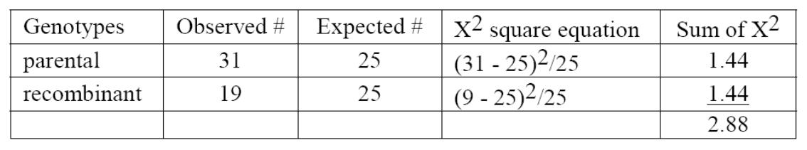
Assumption #1, 50 progeny:
1 dof (degree of freedom), 0.05 < p < 0.1 and the null hypothesis cannot be rejected – the data is compatible with the hypothesis that the genes are assorting independently.
Assumption #2, 50 progeny:
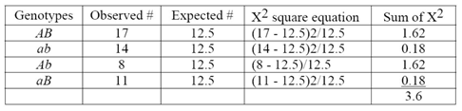
3 dof, 0.10 < p < 0.5 and the null hypothesis cannot be rejected - the data is compatible with the hypothesis that the genes are assorting independently.
Assumption #1, 100 progeny:
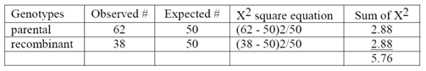
1 dof, 0.01 < p < 0.05 and the null hypothesis is rejected - the genes are not assortingindependently, so they must be linked.
Assumption #2, 100 progeny:
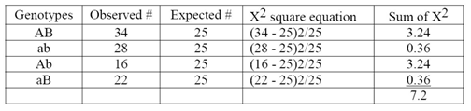
3 dof, 0.05 < p < 0.1 and the null hypothesis cannot be rejected - the data is compatible with the hypothesis that the genes are assorting independently.
b. In the first experiment with only 50 progeny, p < 0.05 using both the 2 class and 4 class assumptions, so neither assumption supports the idea that the genes are linked (although the test with 2 classes is closer to significance). When more progeny are scored, the null hypothesis (that the genes are assorting independently) is rejected when you look at the data as 2 classes but not as 4 classes. This suggests that using 2 classes is a more sensitive test for linkage than using 4 classes.
7．a. Designate the alleles: H = Huntington allele, h = normal allele; B = brachydactyly, b = normal fingers. John's father is bb Hh; his mother is Bb hh.
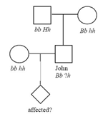
b. We know that John is Bb because he has brachydactyly. His complete genotype could be Bb Hh or Bb hh. The probability that John's genotype is BbHh = 1/2 (chance that he inherited the H allele from his father) × 1/3 (probability of >50 years of age for onset of symptoms) / (1/2 + 1/2 × 1/3) = 1/4. The probability that John's genotype is Bbhh = 3/4.
c. The probability that the child will have and express brachydactyly = 1/2 (probability of inheriting B from John) × 9/10 (probability of expressing the phenotype) = 0.45. The probability that the child will express Huntington's disease by age 50 = 1/4 (probability that John is Hh) × 1/2 (probability that the child will inherit the H allele) × 2/3 (probability the child will show symptoms of Huntington's by age 50) = 1/12. If brachydactyly and Huntington's assort independently, the probability that the child will express both phenotypes by age 50 = 0.45 (probability of expressing brachydactyly) ×1/12 (probability of expressing Huntington's by age 50) = 0.0375 (或3/80).
d. If the two loci are linked, the alleles on each of John’s homologs will be either B h / b H or B h / b h. If it is the former (and John has Huntington's), the B H gamete could only be produced by recombination. The probability of that specific recombinant gamete = 10% (b h constitutes the other 10% of the recombinant gametes). As shown in part a, the probability that John's genotype is B h / b H = 1/4. The probability that John's child will inherit both the Huntington and brachydactyly alleles = 1/4 (probability that John is B h / b H) × 1/10 (probability of child inheriting B H recombinant gamete from John) × 9/10 (probability of expressing brachydactyly) × 2/3 (probability of expressing Huntington's by age 50) = 0.015 (或3/200).

